|  |  |
| --- | --- |
| **Job Number:** | 233409055 |
| **Job title :** | Project Oshun Digital |
| **Fieldwork Start Date :** | May 2021 |

INTRODUCTION

*Length of interview should be quoted in panel invite as it is for* *Kantar Profiles Network.*

*If KANTARDEVICETYPE = PC/LAPTOP, OR TABLET state LOI as 25.*

*If KANTERDEVICETYPE=SMALLTABLET/SMART PHONE WITH TOUCH state LOI as 15*

Welcome!

Thank you for taking part in this survey

We are interested to hear your opinion on Facebook Advertisements!  
Please read the questions carefully and provide clear and honest answers, Do not speed through the survey as that would not count as a valid response.  
  
This survey will take approximately 20 minutes. If you close your browser you will not be able to complete the survey.  
  
In line with data protection laws, the results will only be used for statistical purposes and any personal information will be deleted once no longer needed. For more details please refer to the Kantar Privacy policy, which can be found at www2.kantar.com/za-privacy-cawi.pdf

Click ‘>’ to begin.

**Scripter notes:** Ensure that the URL provided is a clickable link from within the survey.

|  |  |  |
| --- | --- | --- |
| |  |  | | --- | --- | | **START: Start Time** | **Numeric** | |
| |  | | --- | | **Not back | Min = 0 | Max = 9999 | Dummy** | |
| |  | | --- | |  | |

NEW SCREEN

***AVQUALITY***

We would like you to watch a short video to check that you can see it and hear it.

Before pressing the ‘play’ button please turn up the volume.

NEW SCREEN

*TMT ID = jwplayer*

Press the play button.

SHOW one of the following videos

VCAT_ADOG.MP4

Vlion_ArOOster.MP4

***SEEVIDEO***

Which of these animals did you **see**?

|  |  |  |  |  |
| --- | --- | --- | --- | --- |
|  |  |  |  |  |
| Cat | Dog | Elephant | Lion | Rooster |

**ADD** None of these

ONE CODE ONLY. SHOW CLICKABLE IMAGE OF ANIMAL WITH TEXT BELOW IMAGE. RANDOMISE RESPONSES, ANCHOR NONE OF THESE AT THE BOTTOM OF THE LIST.

IF SHOWN VCAT_ADOG.MP4 CLOSE IF THE RESPONDENT DOES NOT SELECT ‘CAT’ AT SEEVIDEO.

IF SHOWN VLION_AROOSTER.MP4 CLOSE IF THE RESPONDENT DOES NOT SELECT ‘LION AT SEEVIDEO.

***HEARVIDEO***

Which of these animals did you **hear**?

|  |  |  |  |  |
| --- | --- | --- | --- | --- |
|  |  |  |  |  |
| Cat | Dog | Elephant | Lion | Rooster |

**ADD** None of these

ONE CODE ONLY. SHOW CLICKABLE IMAGE OF ANIMAL WITH TEXT BELOW IMAGE. RANDOMISE RESPONSES, ANCHOR NONE OF THESE AT THE BOTTOM OF THE LIST.

IF SHOWN VCAT_ADOG.MP4 CLOSE IF THE RESPONDENT DOES NOT SELECT ‘DOG’ AT HEARVIDEO.

IF SHOWN VLION_AROOSTER.MP4 CLOSE IF THE RESPONDENT DOES NOT SELECT ‘ROOSTER’ AT HEARVIDEO.

NEW SCREEN

AGE

Please type in your age…

TYPE IN

SHOW BOX. Limit to 2 digits. CLOSE IF NOT 18-24. IF 18-25SKIP TO SEX.

Do not wish to answer ~ SHOW EXACT AGE REFUSAL DISPLAY SCREEN

EXACT AGE REFUSAL DISPLAY SCREEN

Sorry! We need your exact age for you to continue. Please click ‘>’ to be taken back to the previous screen. If you select ‘Do not wish to answer’ then the survey will close.

AGEBANDS

18 to 25

GENDER

NEWGENDER (GENDER_INCLUSIVE)

What best describes your gender?

Male

Female

I don’t identify as either

Prefer not to answer

RANDOMISE MALE/FEMALE RESPONSES

ADDITIONAL RECRUITMENT

ETH. ETHNIC GROUP

OPTIONAL

We are a proud Rainbow Nation! That is why we would like to know, are you....?

Black

Coloured

Indian/Asian

White

RANDOMISE

PRV. PROVINCE

OPTIONAL

Which province of South Africa do you live in?

Eastern Cape

Free State

Gauteng

KwaZulu – Natal

Limpopo

Mpumalanga

North West

Northern Cape

Western Cape

|  |  |  |  |
| --- | --- | --- | --- |
| |  |  |  | | --- | --- | --- | | |  |  | | --- | --- | | **B006 - B_SEM: SLICK SEM\*** | **Begin block** | | |

|  |  |  |
| --- | --- | --- |
| |  |  | | --- | --- | | **Q008 - SSEM1: Household items** | **Matrix** | |
| |  | | --- | | **Not back | Number of rows: 5 | Number of columns: 2 | Text** | |
| |  | | --- | |  | |
| |  | | --- | | Which of the following do you have in your household? | |
| |  | | --- | | **Rows: Random | Columns: Normal** | |
| |  | | --- | | **Rendered as Dynamic Grid** | |
| |  |  |  |  | | --- | --- | --- | --- | |  |  | [_1] Yes | [_2] No | |  |  | 1 | 2 | | Microwave oven | 1 | ❍ | ❍ | | Flush toilet inside the home | 3 | ❍ | ❍ | | Motor car | 4 | ❍ | ❍ | | Built-in kitchen sink | 5 | ❍ | ❍ | | Home security service | 6 | ❍ | ❍ | |

|  |  |  |
| --- | --- | --- |
| |  |  | | --- | --- | | **Q009 - SSEM2: Post Office** | **Single coded** | |
| |  | | --- | | **Not back | Text** | |
|  |
| |  | | --- | | Do you have a post office near where you live? | |
| |  | | --- | | **Normal** | |
| |  |  |  |  | | --- | --- | --- | --- | | 1 |  | [_1] | Yes | | 2 |  | [_2] | No | |

|  |  |  |
| --- | --- | --- |
| |  |  | | --- | --- | | **Q010 - SSEM_OUTPUT5: 5 Supergroup SEM output** | **Single coded** | |
| |  | | --- | | **Not back | Dummy** | |
| |  | | --- | | The script will ensure that this output is auto-filled based on Slick-SEM-5 segmentation rules | |
| |  | | --- | | **Normal** | |
| |  |  | | --- | --- | | 1 | Supergroup 1 (0-15) | | 2 | Supergroup 2 (16-30 | | 3 | Supergroup 3 (31-65 | | 4 | Supergroup 4 (66-85) | | 5 | Supergroup 5 (86-100) | |
| |  | | --- | | **Scripter notes:** Autofill based on Slick-SEM-5 segmentation rules. RECORD SEM GROUP | |

|  |  |  |  |
| --- | --- | --- | --- |
| |  |  |  | | --- | --- | --- | | |  |  | | --- | --- | | **B006 - B_SEM: SLICK SEM\*** | **End block** | | |

**FACEBOOK USERS**

QFB1

How often do you access Facebook?

10 times a day or more

5-9 times a day

2-4 times a day

Once a day

Once a week

Less Often - CLOSE

Never - CLOSE

DO NOT RANDOMISE OR ROTATE. FORCE ANSWER. ERROR MESSAGE.

Please provide a response to the previous question to continue.

Please click on the 'Answer Question' button below to continue.

CLOSE INTERVIEW IF FACEBOOK NOT ACCESSED ONCE A WEEK OR MORE.

Interest topic questions client would like to ask – TO BE CONFIRMED – Questionnaire length cannot exceed 20 mins

SCRIPTOR INSTRUCTIONS

RESPONDENT IS DIRECTED INTO EYE- SQUARED PLATFORM TO MEASURE BEHAVIOUR METRICS.

RPS1

CORE

Thinking about a range of different issues, how important is each of these issues to you?

*Please answer for each issue*

Climate change

Drug usage amongst young people

Having a healthier lifestyle

Making your neighbourhood a safer place

Reducing road accidents

The amount of alcohol consumed by people

The effects of smoking and passive smoking

Crime prevention

Unemployment or job security

Gender-based violence

*HIV PREVENTION*

Very important

Quite important

Not very important

Not at all important

SEVERAL STATEMENTS PER SCREEN. RANDOMISE STATEMENTS. ONE CODE ONLY PER STATEMENT.

VASEG

VALUE SEGMENTS

For the next few questions, we are interested in learning more about you as a person. Please indicate how strongly you agree or disagree with each of the statements below. Please keep in mind that we want to learn about you. Please avoid using the same scale choice for all/most of your responses.

*Please answer for each issue*

|  |
| --- |
| I choose to abstain from sex and remain a virgin |
| I am confident enough to insist on using a condom when having sex |
| I occasionally have one night stands with people I don't know well |
| I use home remedies to protect myself from contracting HIV/ Aids before or after having sex |
| My family does not allow me to have a boyfriend |
| Friends/family often insult me or deliberately make me feel bad about myself |
| I am comfortable having sex with more than one partner |
| I am comfortable to having sex with an older man in exchange for looking after my financial needs |
| My family is very protective over me and my general well being |
| I am highly influenced by what other people tell me in general |

Strongly Agree

Agree

Neither agree or disagree

Disagree

Strongly disagree

I would prefer not to anser

RANDOMISE STATEMENTS. ONE CODE ONLY PER STATEMENT

*1 - STANDARD* *KANTARPLAYER*

ADINTRO

The ad we'd like you to watch will be shown on the next page within a Facebook setting. Depending on your connection speed, it may take a few seconds to load.

Please be patient, we really want your opinion of this ad.

NEW SCREEN

KANTARPLAYER playvideo

Press the play button.

PLAY THE CLIENT TEST AD ONCE USING STANDARD KANTARPLAYER

▶

NEW SCREEN

We would like you to view the ad one more time.

ALLOW RESPONDENT TO VIEW ADVERT BEFORE PROCEEDING

▶

SKIP TO Q6 ENJOYMENT

QPS5

CORE

How much would this advert grab your attention?

Definitely would grab my attention

Probably would grab my attention

Probably would not grab my attention

Definitely would not grab my attention

ONE CODE ONLY

ENJOYMENT

Q6

CORE

How much would you enjoy watching this ad each time you see it on Facebook?

A lot

Quite

Wouldn’t mind

Not much

Not at all

ONE CODE ONLY

ACTIVE INVOLVEMENT

Q7/8/9

CORE

Please select one word from each of these three lists that applies most to the ad.

Pleasant

Interesting

Boring

Irritating

Soothing

Distinctive

Dull

Unpleasant

Gentle

Involving

Weak

Disturbing

CLICKABLE TEXT

DISPLAY ALL 3 LISTS ON ONE SCREEN HORIZONTALLY FOR DESKTOP, VERTICALLY FOR MOBILE IN ORDER SHOWN. ONE CODE ONLY PER LIST.

KEEP SAME WORDS IN EACH LIST OF 4 WORDS – RANDOMISE ORDER OF WORDS WITHIN EACH LIST

**STANDARD BRANDING QUESTION**

*In Public Sector CREATIVE ‘branding’ is about how well the issue at the heart of the campaign is coming through. Even if the campaign has an umbrella brand (e.g. Act on CO2 or THINK!, the driving safety campaign) the question is asked about how well the broad topic/HIV PREVENTION MARKETING came through. e.g. “you couldn’t fail to remember the advertising was about reducing carbon emissions” (for the Act on CO2 campaign). See Public Sector Link™ Questionnaire Rationale document for further guidance on wording of ‘branding’ aspect.*

STANDARD BRANDING

Q11a

CORE

Thinking about the ad you’ve just seen for HIV PREVENTION, which one of these phrases applies to this ad?

You couldn't fail to remember it was for HIV PREVENTION

It is quite good at making you remember it is for HIV PREVENTION It is not all that good at making you remember it is for HIV PREVENTION

It could have been for part of any HIV PREVENTION campaign.

It could have been for almost anything

ONE CODE ONLY.

______________________________________________________________________________________________

BRAND CUES

Q12

CORE

How easily could you tell that that the visual was for HIV PREVENTION?

Very easily

Quite easily

Not very easily

Not at all easily

ONE CODE ONLY

_____________________________________________________________________________________________

*These questions are designed to understand the propensity of the advertising to encourage behaviour change.*

*QPS13 should be tailored to help us understand where respondents currently sit in relation to the test issue.*

*Example from pilot work:*

*• I’m very aware of crime prevention issues…*

*• I’m very aware of my ‘carbon footprint’…*

*• I regularly drive over the speed limit…*

*QPS14 should be tailored to help understand how likely the ads will be to encourage behaviour change.*

*Example from pilot work:*

*• Make(s) me much more likely to try to take precautions to prevent crime*

*• Make(s) me much more likely to take steps to reduce my carbon emissions*

*• Make(s) me much less likely to drive over the speed limit*

*• Make(s) me much more likely to stop smoking*

QPS13

CORE

Click on the phrase which applies to you most.

|  |  |
| --- | --- |
| I’m very aware of HIV PREVENTION ~~MARKETING~~ issues |  |
| I try to be aware of HIV PREVENTION issues |  |
| I TEND NOT TO/ DON’T USUALLY think about HIV PREVENTION issues |  |
| I never think about HIV PREVENTION issues |  |
| I don’t really know what a HIV PREVENTION is about |  |

ONE CODE ONLY

QPS14

CORE

How would the advert affect what you do about HIV PREVENTION?

*Tailor response list based on either of the 2 examples shown below*

|  |  |
| --- | --- |
| Makes me much more likely to BEHAVE / TAKE ACTION ON WHAT THE AD IS TRYING TO ENCOURAGE |  |
| Makes me a little more likely to try to BEHAVE / TAKE ACTION ON WHAT THE AD IS TRYING TO ENCOURAGE |  |
| Makes no difference |  |
| Puts me off BEHAVING/ ACTIONING ON WHAT THE AD IS TRYING TO ENCOURAGE |  |

ONE CODE ONLY

_____________________________________________________________________________________________

*These questions are also designed to help us understand behaviour change but work at the attitudinal change level which might happen before actual behaviour change is achieved.*

*Examples:*

*Strongly reminded me about the importance of reducing my carbon emissions*

*Slightly reminded me about the importance of reducing my carbon emissions*

*It didn't remind me at all about the importance of reducing my carbon emissions*

*If anything it put me off thinking about reducing my carbon emissions*

*Strongly reminded me that I shouldn’t drive over the speed limit*

*Slightly reminded me that I shouldn’t drive over the speed limit*

*It didn't remind me at all about the importance of not driving over the speed limit*

*If anything it made me feel that I shouldn't drive within the speed limit*

ASK QPS15 TO RESPONDENTS WHO SAID 'I don't usually think about HIV PREVENTION ~~MARKETING~~, 'I never think about HIV PREVENTION ’ OR 'I don't really know what HIV PREVENTION is' AT QPS13. OTHERWISE SKIP TO QPS16. *Tailor instruction to wording used in bottom 2 or 3 responses at QPS13*

QPS15

CORE

How did the advert make you feel about HIV PREVENTION? The advert made me feel. . .

Much more strongly that I should think about HIV PREVENTION

A little more strongly that I should think about HIV PREVENTION

It didn't change my feelings about HIV PREVENTION

If anything it put me off thinking about HIV PREVENTION

ONE CODE ONLY

ASK QPS16 TO RESPONDENTS WHO SAID 'I'm very aware of HIV PREVENTION OR 'I try to be aware of HIV PREVENTION MARKETING AT QPS13. OTHERWISE SKIP TO OP19/Q21. *Tailor instruction to wording used in top 2 responses at QPS13*

QPS16

CORE

How did the advert make you feel about HIV PREVENTION? The advert...

Strongly reminded me about the importance of HIV PREVENTION

Slightly reminded me about the importance of HIV PREVENTION

It didn't remind me at all about the importance of HIV PREVENTION

If anything it put me off thinking about HIV PREVENTION

ONE CODE ONLY

BRAND APPEAL

Q20

CORE

How did the ad make you feel about HIV PREVENTION MARKETING? The ad made HIV PREVENTION seem . . .

Much more appealing

A little more appealing

It didn't change my feelings about HIV PREVENTION MARKETING

A little less appealing

Much less appealing

ONE CODE ONLY

AD DISTINCTIVENESS

Q24

CORE

How different is this ad to other advertising that you have seen?

Very different to any other advertising

Quite different to any other advertising

Not very different to other advertising

Not at all different to other advertising

ONE CODE ONLY

Ad Distinctiveness within category

op24B

OPTIONAL

How different is this ad to other advertising that you have seen for HIV Prevention awareness

Very different to any other advertising for HIV Prevention awareness

Quite different to any other advertising for HIV Prevention awareness

Not very different to other advertising for HIV Prevention awareness

Not at all different to other advertising for HIV Prevention awareness

IMINTRO

CORE

Imagine you are having a conversation with someone you know about the ad.

LIKES MODIFIED

OP26a

OPTIONAL ~~–~~

Tell me everything you liked about the ad.

OPEN, CONTINUE AS IM CONVERSATION

DISLIKES MODIFIED

OP26b

OPTIONAL

Tell me everything you disliked about the ad.

OPEN, CONTINUE AS IM CONVERSATION

_____________________________________________________________________________________________

PERCEIVED UNDERSTANDING

Q32

CORE

How easy was it to understand what was going on in the post?

Very easy

Quite easy

Quite hard

Very hard

ONE CODE ONLY

RELEVANCE OF INFORMATION

Q33

CORE

How relevant would the points made in the Facebook post be to you?

Very relevant

Quite relevant

Not very relevant

Not at all relevant

ONE CODE ONLY

CREDIBILITY OF INFORMATION

Q34

CORE

How strongly do you agree or disagree that what the ad puts across about HIV PREVENTION is believable?

Agree strongly

Agree slightly

Neither agree nor disagree

Disagree slightly

Disagree strongly

ONE CODE ONLY

NEW INFORMATION

Q35

CORE

How much new information does the ad give you about HIV PREVENTION?

A lot of new information

Some new information

No new information

No information at all

ONE CODE ONLY

BRAND DIFFERENCE

Q36

CORE

How strongly do you agree or disagree that the ad makes you think this brand (marketing / advertising ) is really different from others?

Agree strongly

Agree slightly

Neither agree nor disagree

Disagree slightly

Disagree strongly

ONE CODE ONLY

MEETS NEEDS (DELIVERS MAIN THINGS)

Q36a

CORE

How strongly do you agree or disagree that the ad makes you think it delivers the main information you need from a HIV PREVENTION CAMPAIGN?

Agree strongly

Agree slightly

Neither agree nor disagree

Disagree slightly

Disagree strongly

ONE CODE ONLY

DYNAMIC (SETS TRENDS)

Q36b

CORE

How strongly do you agree or disagree that the ad makes you think it sets trends?

Agree strongly

Agree slightly

Neither agree nor disagree

Disagree slightly

Disagree strongly

ONE CODE ONLY

__________________________________________________________________________________________

*MESSAGE CHECK*

OP36

CORE

Having seen the ad, how likely is it that this message will stick in your mind?

*Minimum 1 and Maximum of 6 statements*

*Insert your messages in priority order at ‘messageCheck1’, ‘messageCheck2’ ,*

*‘messageCheck3’ etc.*

*MESSAGES SHOULD BE IN LINE WITH WHAT THE POST ARE TRYING TO ENCOURAGE and INTEND*

|  |  |
| --- | --- |
| *MessageCheck1* | BRANDNAME message 1 |
| *MessageCheck2* | BRANDNAME message 2 |
| *MessageCheck3* | BRANDNAME message 3 |
|  |  |
|  |  |
|  |  |

Very likely

Quite likely

Probably wouldn’t

Definitely wouldn’t

SHOW AS DYNAMIC GRID. BLANK ADJACENT CARDS. AUTO ADVANCE AND BACK BUTTON ENABLED. RANDOMISE STATEMENT ORDER. ALIGN RESPONSES HORIZONTALLY. ONE CODE ONLY PER STATEMENT.

OP36_Post 1

CORE ( the picture will not be scripted here, I have included it to help navitage the key messages)

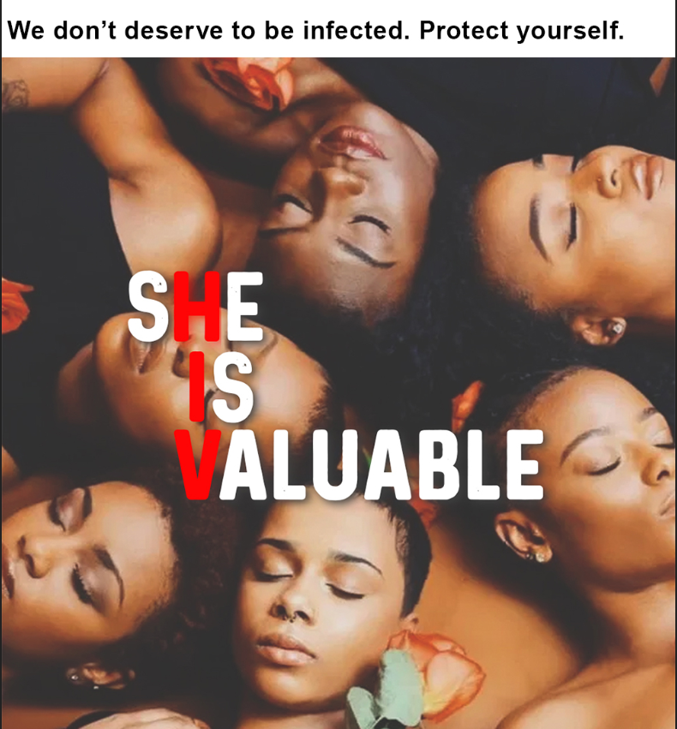

Having seen the ad, how likely is it that this message will stick in your mind?

|  |  |
| --- | --- |
| *MessageCheck1* | Empowers me to protect myself from HIV |
| *MessageCheck2* | Protect yourself from HIV |
| *MessageCheck3* | We don’t deserve to be infected by HIV |
|  |  |
|  |  |
|  |  |

SHOW AS DYNAMIC GRID. BLANK ADJACENT CARDS. AUTO ADVANCE AND BACK BUTTON ENABLED. RANDOMISE STATEMENT ORDER. ALIGN RESPONSES HORIZONTALLY. ONE CODE ONLY PER STATEMENT

OP36_Post 2

CORE ( the video will not be scripted here, I have included it to help navitage the key messages)



Having seen the ad, how likely is it that this message will stick in your mind?

|  |  |
| --- | --- |
| *MessageCheck1* | Empowers me to protect myself from HIV |
| *MessageCheck2* | Protect yourself from HIV |
| *MessageCheck3* |  |
|  |  |
|  |  |
|  |  |

SHOW AS DYNAMIC GRID. BLANK ADJACENT CARDS. AUTO ADVANCE AND BACK BUTTON ENABLED. RANDOMISE STATEMENT ORDER. ALIGN RESPONSES HORIZONTALLY. ONE CODE ONLY PER STATEMENT

OP36_Post 3

CORE ( the video will not be scripted here, I have included it to help navitage the key messages)



Having seen the ad, how likely is it that this message will stick in your mind?

|  |  |
| --- | --- |
| *MessageCheck1* | Empowers me to protect myself from HIV |
| *MessageCheck2* | Wear fearlessness with pride |
| *MessageCheck3* | Protect yourself from HIV |
|  |  |
|  |  |
|  |  |

SHOW AS DYNAMIC GRID. BLANK ADJACENT CARDS. AUTO ADVANCE AND BACK BUTTON ENABLED. RANDOMISE STATEMENT ORDER. ALIGN RESPONSES HORIZONTALLY. ONE CODE ONLY PER STATEMENT

OP36_Post 4

CORE ( the video will not be scripted here, I have included it to help navitage the key messages)

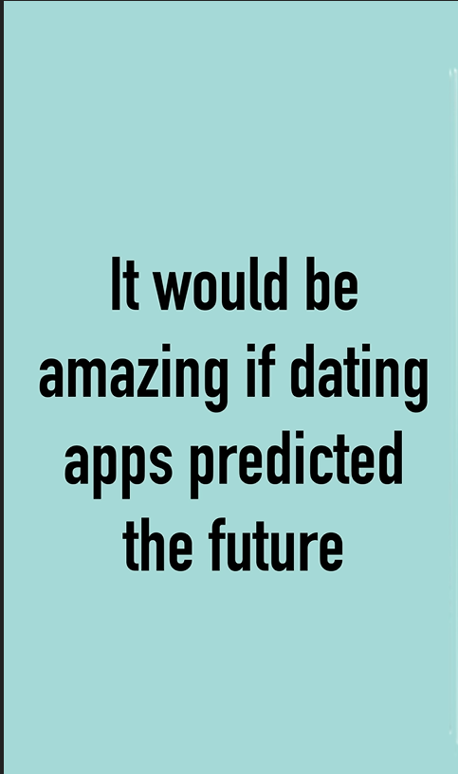

Having seen the ad, how likely is it that this message will stick in your mind?

|  |  |
| --- | --- |
| *MessageCheck1* | Empowers me to protect myself from HIV |
| *MessageCheck2* | Dating apps don’t predict the future |
| *MessageCheck3* | Protect yourself from HIV |

SHOW AS DYNAMIC GRID. BLANK ADJACENT CARDS. AUTO ADVANCE AND BACK BUTTON ENABLED. RANDOMISE STATEMENT ORDER. ALIGN RESPONSES HORIZONTALLY. ONE CODE ONLY PER STATEMENT

OP36_Post 5

CORE ( the picture will not be scripted here, I have included it to help navitage the key messages)

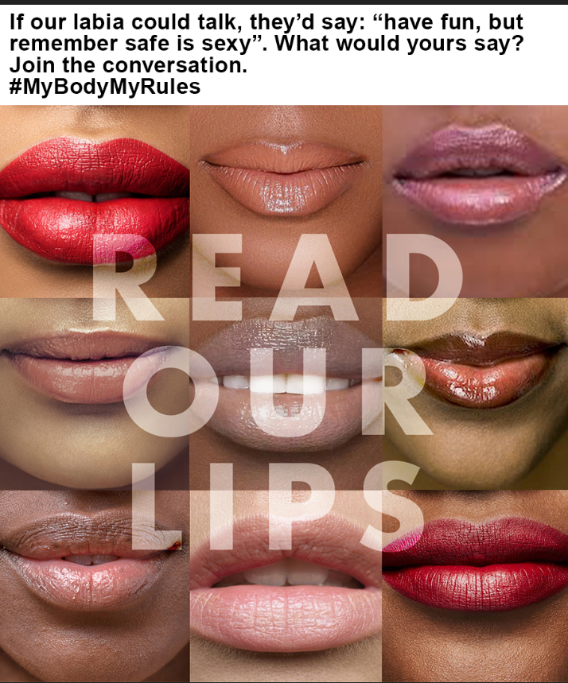

Having seen the ad, how likely is it that this message will stick in your mind?

|  |  |
| --- | --- |
| *MessageCheck1* | Empowers me to protect myself from HIV |
| *MessageCheck2* | My body my rules |
| *MessageCheck3* | Protect yourself from HIV |

SHOW AS DYNAMIC GRID. BLANK ADJACENT CARDS. AUTO ADVANCE AND BACK BUTTON ENABLED. RANDOMISE STATEMENT ORDER. ALIGN RESPONSES HORIZONTALLY. ONE CODE ONLY PER STATEMENT

TELL OTHER PEOPLE

Q58

CORE

Is this an ad that you would tell other people about?

Definitely

Possibly

No

ONE CODE ONLY

VIRAL PASS ALONG

Q59

CORE

If you saw this ad online, would you share it with someone so they could watch it?

Definitely

Possibly

No

ONE CODE ONLY

GENDER PORTRAYAL QUESTIONS

GENDER PORTRAYAL TYPE (TO BE SPECIFIED BY CS)

*Please indicate which GENDER PORTRAYAL is needed based on what is featured in the ad.*

*Guidelines:*

* *If there is no gender featured in the ad, do not include any GENDER PORTRAYAL questions (e.g. cartoon of product pack, cartoon voiceover)*
* *If there is no gender featured but does have a male or female voiceover, do not include any GENDER PORTRAYAL questions*
* *If you have female character(s) only, include GENDER PORTRAYAL TYPE 1 only*
* *If you have male character(s) only, include GENDER PORTRAYAL TYPE 2 only*
* *If you have both female and male character(s), include GENDER PORTRAYAL TYPE 3*
* *Include GENDER PORTRAYAL questions even if the appearance of either female or male characters is minimal (e.g. a photo of woman is show briefly)*

***Statement wording must NEVER be changed*** *(even if the ad only contains one woman, or a girl not a woman etc)*

|  |  |  |
| --- | --- | --- |
| Female characters/actors only shown in test ad | GENDER PORTRAYAL TYPE = 1 | SHOW GENDERPORTRAYAL1 ONLY |
| Male characters/actors only shown in test ad | GENDER PORTRAYAL TYPE = 2 | SHOW GENDERPORTRAYAL2 ONLY |
| Both Female and Male characters/actors shown in test ad | GENDER PORTRAYAL TYPE = 3 | SHOW BOTH GENDERPORTRAYAL1/ GENDERPORTRAYAL2 |

GENDERPORTRAYAL1/2 TO BE ASKED BEFORE ADDITIONAL CLIENT CUSTOM QUESTIONS.

IF GENDER PORTRAYAL TYPE = 1 OR 3 ASK GENDERPORTRAYAL1 OTHERWISE SKIP TO GENDERPORTRAYAL2

FEMALE GENDER PORTRAYAL QUESTION

GENDERPORTRAYAL1

CORE (IF FEMALE CHARACTERS SHOWN)

How much do you agree with the following statements?

|  |  |
| --- | --- |
| GEM | I think highly of the way women are presented in the ad |
| GEM | Women are presented in a respectful manner in the ad |
| GEM | It is inappropriate how women are featured in the ad |
| GEM | Women are presented in the ad in a manner where they can be seen as good role models for other women and young girls |
| UM | This advertising presents a positive image of the female character/s that sets a good example for others |

Strongly agree

Slightly agree

Neither agree nor disagree

Slightly disagree

Strongly disagree

SHOW AS DYNAMIC GRID. BLANK ADJACENT CARDS. AUTO ADVANCE AND BACK BUTTON ENABLED. DO NOT RANDOMISE STATEMENTS. ALIGN RESPONSES HORIZONTALLY.

IF GENDER PORTRAYAL TYPE = 2 OR 3 ASK GENDERPORTRAYAL2 OTHERWISE SKIP

MALE GENDER PORTRAYAL QUESTION

GENDERPORTRAYAL2

CORE (IF MALE CHARACTERS SHOWN)

How much do you agree with the following statements?

|  |  |
| --- | --- |
| GEM | I think highly of the way men are presented in the ad |
| GEM | Men are presented in a respectful manner in the ad |
| GEM | It is inappropriate how men are featured in the ad |
| GEM | Men are presented in the ad in a manner where they can be seen as good role models for other men and young boys |
| UM | This advertising presents a positive image of the male character/s that sets a good example for others |

Strongly agree

Slightly agree

Neither agree nor disagree

Slightly disagree

Strongly disagree

SHOW AS DYNAMIC GRID. BLANK ADJACENT CARDS. AUTO ADVANCE AND BACK BUTTON ENABLED. DO NOT RANDOMISE STATEMENTS. ALIGN RESPONSES HORIZONTALLY.

CLIENT SPECIFIC QUESTIONS

MOOD AND FEEL

OP42

Here are some words that people have used to describe the mood and feel of this ad. Please select the words you think apply to the ad.

|  |  |
| --- | --- |
|  |  |
| *1* | *Fun* |
| *4* | *Lively* |
| *5* | *Original* |
| *10* | *Empowerinf* |
| *11* | *Modern* |
| *8* | *Refreshing* |
| *50* | *Positive* |
| *51* | *Genuine* |
| *20* | *Convincing* |
| *21* | *Uplifting* |
| *28* | *Honest* |
| *32* | *Assertive* |
| *33* | *Reassuring* |
| *41* | *Imaginative* |
| *43* | *Sexy* |
| *53* | *Edgy* |
|  | None of these |
|  |  |

RANDOMISE WORDS

*ADSPB and Respondent Satisfaction Questions are not counted towards questionnaire length.*

ADSPB

CORE

Did you have any problems with the ad playback at the beginning of the survey?

Yes

No

YOB: YEAR OF BIRTH

Min = 1900 | Max = 2019

CORE (DO NOT DELETE)

What year were you born in?

EOS: EASE OF SURVEY

CORE (DO NOT DELETE)

It was easy to answer the questions in this survey…

Strongly agree

Somewhat agree

Neither

Somewhat disagree

Strongly disagree

SEN: SURVEY ENJOYMENT

CORE (DO NOT DELETE)

Overall was this survey….?

Very enjoyable

Somewhat enjoyable

Not very enjoyable

Not at all enjoyable

NEW SCREEN

END SCREEN : panelDetails.endText.complete

You have completed the survey. Thank you for your time. You can access Kantar's website for additional information on our data privacy policy including complaints procedure, how to contact the data protection officer or request removal of your personal information.

Click ‘Submit’ to finish.

SUBMIT

|  |  |  |
| --- | --- | --- |
| |  |  | | --- | --- | | **IntEnd: End Time** | **Numeric** | |
| |  | | --- | | **Not back | Min = 0 | Max = 9999 | Dummy** | |
| |  | | --- | |  | |

SPD_DEF: SPEEDSTER DEFINITION (DO NOT DELETE)

CORE. (DO NOT DELETE)

1. ##SPEEDSTER DURATION##

*Insert the number of minutes considered too quick to complete this survey in, thereby deeming this interview “suspicious”. The recommendation is 15% of the expected interview duration. Insert number only)*

DO NOT DELETE THIS QUESTION: It is used in the background script for panel quality-control purposes

